HUMAN-COMPUTER INTERACTION (HCI) • CASE STUDY EVALUATION REPORT
ISO 9241-210 Human-Centered Design Evaluation of the Electronic Real Property Tax System (DICT eRPT)
A Comparative Benchmark Evaluation for the Proposed Real Property Assessment Tracking and Inter-Office Synchronization System
Authors / Group: | Group 23 • Christian Louise O. Asido, John Kenneth P. Calubad, Rizalina A. Ortega
Institution / Term: | School of Computer and Information Sciences, University of Nueva Caceres • AY 2026–2027

A. System Overview
The Department of Information and Communications Technology (DICT) developed the Electronic Real Property Tax System (eRPT). Local Government Units (LGUs) deploy the software to automate property appraisal, assessment calculation, and tax collection. LGUs install the system on municipal servers or provincial data centers. The architecture uses relational database engines and server application logic. The platform provides modules for Real Property Assessment, Land Tax Billing, and Treasury Cashiering.
The primary objective of DICT eRPT is to computerize municipal tax administration under Republic Act 7160. Municipal assessors record Field Appraisal and Assessment Sheets (FAAS) for land, buildings, and machinery. The software applies statutory assessment levels and schedules of market values to compute assessed values. It generates computerized Tax Declarations and transfers assessment records to municipal treasury ledgers. Treasury cashiers query tax records and issue Official Receipt Form 56 upon payment.
DICT eRPT connects directly to the proposed project as an empirical operational benchmark. The Municipality of Pasacao, Camarines Sur, adopted DICT eRPT in 2021 and upgraded the platform in 2024. Field interviews with municipal personnel in Pasacao reveal critical workflow bottlenecks. Although eRPT automates mathematical tax calculations, it lacks automated inter-office synchronization. Staff must prepare and upload batch Excel files to update collection records between departments. The software provides no tracking monitor for assessment endorsements routed to the Provincial Capitol in Pili. Property transfers take more than seven days to complete due to manual document routing. The proposed system directly resolves these operational barriers. It implements a three-tier web architecture with automated inter-office synchronization and real-time document milestone tracking.
B. Identified Users and Context of Use
Human-Centered Design requires an explicit understanding of user groups, tasks, tools, and environments under ISO 9241-210 Clause 6.2. Field research and system reviews identify distinct user groups and operational environments in municipal halls:
1. Primary User Groups
- Municipal Assessor Personnel (Tax Mappers, Appraisers, Municipal Assessor): Staff record parcel boundaries and encode FAAS records. They calculate assessed values and prepare computerized Tax Declarations. They approve property subdivisions and title transfers. They interact with tabular data entry forms and consult physical archive ledgers.
- Municipal Treasurer Personnel (Revenue Clerks, Cashiers, Liquidators): Cashiers search property tax obligations using Property Index Numbers. They collect cash payments and print Official Receipt Form 56. They manage accountable paper receipt forms and prepare daily remittance reports.
- Local IT and MIS Officers: Administrators configure local tax rates and schedules of market values. They install system updates on municipal servers, execute database backups, and troubleshoot network connections across office terminals.
2. Secondary User Groups
- Property Owners and Local Taxpayers: Citizens visit municipal halls to declare real property and check tax balances. They pay annual realty taxes and request certified copies of tax declarations. They wait in physical queues and interact directly with counter clerks.
- Provincial Assessor Reviewers: Provincial officers at the Camarines Sur Provincial Capitol in Pili inspect municipal assessment rolls. They examine building appraisals, review assessment transfers, and approve general property revisions under statutory rules.
3. Context of Use, Hardware, and Environmental Conditions
Personnel operate the software inside municipal halls during government business hours (8:00 AM to 5:00 PM, Monday to Friday). Transaction volume increases during January discount periods and quarterly deadlines, causing severe office congestion.
The operational environment introduces substantial physical and technical constraints:
- Hardware and Terminals: Clerks operate desktop personal computers running Windows operating systems connected to a local municipal server. Cashiers use dedicated dot-matrix impact printers to print multi-copy accountable Form 56 receipts.
- Network Infrastructure: Workstations communicate over local area networks. Rural municipalities experience unstable internet connections, which prevents continuous cloud connectivity.
- Physical Office Environment: Public service counters experience high ambient noise, crowded queues, and warm room temperatures. Frequent electrical power outages interrupt municipal computer operations.
- Legacy Paper Ledgers: Staff must manually examine historical paper ledgers dating back to 1949 stored on open shelves. They verify historical records before entering property data into the computer system.
C. Usability Strengths and Issues
Evaluating DICT eRPT reveals distinct technical accomplishments alongside critical usability bottlenecks:
1. Usability Strengths
- Automated Statutory Calculations: The system automatically calculates basic property taxes and Special Education Fund levies. It applies prompt payment discounts (10% to 20%) and statutory monthly delinquency interest under RA 7160. This automation eliminates manual arithmetic calculation errors.
- Regulatory Form Production: The system prints official government documents directly. These documents include the Field Appraisal and Assessment Sheet, Tax Declaration, and Notice of Assessment. Clerks recognize these standard layouts quickly.
- Accountable Forms Inventory Control: The software records Official Receipt Form 56 serial numbers sequentially. This control prevents duplicate receipt entries and satisfies Commission on Audit regulations.
- Role Separation: The application enforces strict access boundaries between assessor appraisal entry and treasury cashiering. This security control prevents unauthorized valuation changes during payment collection.
2. Usability Issues and Operational Pain Points
- Manual Excel Batch Upload Overhead: DICT eRPT requires clerks to upload manual Excel spreadsheets to transfer collection records. Incomplete spreadsheets cause database upload failures and require manual data cleansing.
- Disconnected Inter-Office Workflows: The software does not synchronize assessment valuation changes with treasury collection ledgers in real time. Clerks must manually cross-check records between offices, causing administrative delays.
- Zero Milestone Tracking for Provincial Approvals: The system provides no tracking monitor for documents routed to Pili Capitol. Property transfers take 7 to 14 days without digital status visibility for staff or citizens.
- Absence of Citizen Self-Service: Taxpayers cannot submit transfer requirements online or check assessment progress. Citizens must visit municipal counters repeatedly to ask about application statuses.
- Cognitive Fatigue from Dense Data Screens: Screen layouts display dense data tables and nested tabs without progressive disclosure. Prolonged data entry causes eye strain and clerical encoding errors during peak tax seasons.
D. Evaluation Using ISO 9241-210 Framework
The ISO 9241-210:2010 standard defines requirements and recommendations for human-centered design throughout interactive system life cycles. Table B.1 in Annex B provides the official checklist to assess compliance. DICT eRPT was evaluated against this checklist using published research, technical documentation, and field observations in Pasacao.
Synthesis of Human-Centered Design Conformance
DICT eRPT achieves high effectiveness in statutory tax accounting and regulatory compliance. However, the system fails human-centered design conformance across multiple life cycle dimensions of ISO 9241-210:2010. The platform reflects an engineering-driven approach rather than a user-centered design paradigm.
Under Clause 4 (Human-Centered Design Principles), the system satisfies Principle 4.2 by defining clear roles for assessors and cashiers. It satisfies Principle 4.6 by matching automated calculations with municipal statutory tasks. However, it fails Principles 4.3 and 4.4. Development was consultant-driven without active participatory design sessions with municipal clerks. Software updates addressed legal policies and payment gateway features rather than user interaction needs. DICT recorded no formal usability evaluations or user satisfaction tests.
Under Clause 5 (Planning Human-Centered Design), conformance is poor. DICT integrated database engineering and public finance expertise, but omitted human-centered design activities. Project plans focused on server deployment, database integrity, and tax formulas. The agency established no formal procedures to evaluate usability risks or balance human-system trade-offs.
Under Clause 6 (Human-Centered Design Activities), the system achieves mixed results. Under Clause 6.2 (Context of Use), technical server requirements and municipal roles are documented. However, user cognitive workloads, office noise, and electrical power interruptions were ignored. Under Clause 6.3 (User Requirements), functional legal requirements under RA 7160 are complete, but measurable usability criteria were omitted.
Under Clause 6.4 (Design Solutions), automated tax calculations support task suitability under ISO 9241-110 dialogue principles. However, the software fails self-descriptiveness and suitability for individualization. Fixed screen layouts present dense data grids without inline guidance. Under Clause 6.5 (Design Evaluation), acceptance in adopting LGUs relies entirely on financial balance reconciliations. No empirical usability tests or long-term user performance tracking were performed.
E. Recommendations for Improvement and Connection to the Proposed System
Based on the ISO 9241-210 checklist findings, five concrete design recommendations are established for DICT eRPT. Each recommendation directly informs the architectural and interaction design of the proposed system:
- 1. Deploy a Browser-Based Three-Tier Web Architecture: DICT eRPT relies on municipal server installations that burden local IT staff. Recommendation: Migrate the user interface to modern web standards. Lesson Applied to the Proposed System: The proposed system deploys a three-tier web architecture with a browser presentation layer. Personnel access the software on standard office computers without installing local client software.
- 2. Integrate an Assessment Request Routing and Milestone Tracking Module: DICT eRPT lacks multi-office workflow tracking, causing 7 to 14 days of unmonitored delays during property transfers. Recommendation: Build an automated workflow engine that records document transfer milestones with real-time timestamps. Lesson Applied to the Proposed System: The proposed system builds an Assessment Request Routing Module with an Administrative Workflow Panel. The module tracks document status between the Assessor, Treasurer, and Provincial Capitol in Pili, eliminating unmonitored delays.
- 3. Build an Automated Inter-Office Data Synchronization Engine: DICT eRPT requires manual Excel spreadsheet uploads to share assessment and collection data. Recommendation: Connect assessment rolls directly to collection databases using real-time service endpoints. Lesson Applied to the Proposed System: The proposed system features a Tax Payment Synchronization Module. This module links assessment records to collection ledgers in real time, eliminating manual cross-checking between municipal offices.
- 4. Implement Progressive Disclosure and Form Chunking: DICT eRPT displays dozens of input fields on crowded appraisal screens, causing operator fatigue. Recommendation: Divide lengthy appraisal and assessment forms into step-by-step entry screens with inline validation alerts. Lesson Applied to the Proposed System: The proposed system uses guided appraisal entry forms with clear input tooltips and validation alerts. This design reduces cognitive load and prevents encoding errors.
- 5. Conduct Iterative Formative Usability Testing under ISO/IEC 25010: DICT omitted user-centered usability testing during software development. Recommendation: Evaluate usability with representative municipal clerks throughout development. Lesson Applied to the Proposed System: The proposed system adopts an Agile development model with two-week sprints. The team tests the software with municipal personnel in Pasacao, Canaman, Magarao, and San Fernando using ISO/IEC 25010 standards.
--- PART II: COMPLETED ISO 9241-210:2010 CONFORMANCE CHECKLIST ---
Attachment: Completed ISO 9241-210:2010 Conformance Checklist (Table B.1)
This checklist evaluates DICT eRPT against the official ISO 9241-210:2010 Annex B Table B.1 standard. In accordance with strict evaluation protocol, requirements and recommendations lacking verifiable public documentation or published empirical records are marked 'No' in conformance, with explanatory analysis provided in the comments.
Clause | Requirement / Recommendation | Applicable (Y/N) | Reason N/A | Met Y | Met N | Evaluation Comments & Evidence
4.1 | Human-centred approach follows principles in 4.1 | Y |  |  | N | Architecture prioritized statutory tax rules and database consistency over human-centred design processes.
4.2 | Design takes account of people using system and affected stakeholders | Y |  | Y |  | Identifies direct municipal assessor and treasurer staff. Secondary taxpayers have limited system affordances.
4.2 | All relevant user and stakeholder groups identified [see 6.2.2 a)] | Y |  | Y |  | Formal user roles exist for Appraiser, Tax Mapper, Municipal Assessor, Cashier, and Treasury Liquidator.
4.3 | User involvement is active | Y |  |  | N | Records show central agency deployment without active participatory user design sessions in municipal halls.
4.3 | Users involved reflect capabilities, characteristics, and experience [6.2.2 b)] | Y |  |  | N | System assumes trained operators. It does not account for varied digital literacy among rural municipal clerks.
4.4 | User-centred evaluation takes place as part of final product acceptance | Y |  |  | N | Acceptance in adopting LGUs relies on financial balance audits and statutory rule compliance, not usability tests.
4.5 | Iteration used to progressively eliminate uncertainty during development | Y |  | Y |  | DICT released software updates to enhance tax calculations and municipal server deployments across LGUs.
4.6 | User experience of previous systems and branding considered | Y |  | Y |  | Screen input fields replicate paper tax forms. This design preserves familiar mental models for office clerks.
4.6 | Users' strengths, limitations, preferences, and expectations considered in function allocation | Y |  |  | N | Heavy manual data entry burdens clerks. The system lacks automated validation aids or document scanning ingestion.
4.6 | Representative users involved in decisions on allocation of function | Y |  |  | N | No records show end-user participation in allocating automated versus manual system tasks during development.
4.6 | Human activities resulting from function allocation form a meaningful set of tasks | Y |  | Y |  | Clerks complete distinct workflows for property valuation updates, tax declarations, and official receipt issuance.
4.7 | Human-centred design team includes multidisciplinary skills and perspectives | Y |  |  | N | The development team included software engineers and tax specialists. UX and ergonomics experts were omitted.
5.1 | Human-centred design planned and integrated into all life cycle phases | Y |  |  | N | Project records show no human-centred design integration during software conception or engineering.
5.2 a) | Evaluate how usability relates to purpose and use of product | Y |  |  | N | Project scope focused on statutory compliance with RA 7160 rather than formal usability evaluations.
5.2 b) | Evaluate levels of risk resulting from poor usability | Y |  |  | N | Inadequate usability caused documented training delays and slow operational adoption in rural LGUs.
5.2 c) | Evaluate nature of development environment | Y |  |  | N | The server-client architecture was selected for local data control rather than user interaction convenience.
5.3 a) | Identify appropriate HCD methods and resources for Clause 6 activities | Y |  |  | N | Published records show no allocation of human-centred research methods or usability testing resources.
5.3 b) | Define procedures for integrating HCD activities with system development | Y |  |  | N | Development followed engineering milestones that prioritized database schemas and network service stability.
5.3 c) | Identify individuals/organizations responsible for HCD activities and skills | Y |  |  | N | Roles were assigned for software programming, database administration, and tax law consulting, omitting HCD leads.
5.3 d) | Develop feedback and communication procedures on HCD and trade-offs | Y |  |  | N | Agency schedules prioritized statutory deployment deadlines over iterative user design cycles.
5.3 e) | Agree on appropriate milestones for HCD integrated into schedule | Y |  |  | N | System specifications emphasize transactional integrity and database constraints over human interaction quality.
5.3 f) | Agree on suitable timescales for iteration and incorporating user feedback | Y |  |  | N | Design reviews focused on Local Government Code calculation accuracy rather than user task efficiency.
5.4 | HCD plan forms part of overall system development project plan | Y |  |  | N | System milestones lacked gates requiring validation of human factors or operator workload limits.
5.4 | HCD plan subject to same project disciplines as other key activities | Y |  |  | N | Vendor support teams deliver technical bug fixes but do not monitor interaction ergonomics.
5.4 | HCD aspects of project plan reviewed and revised as requirements change | Y |  |  | N | Software changes occur when national tax laws change, not when operators report interface friction.
5.5 | Project planning allocates time and resources to HCD activities | Y |  |  | N | Training manuals focus on software data entry procedures rather than task ergonomics.
5.5 | Plan includes time for iteration and user feedback on user requirements | Y |  |  | N | Deployment plans omitted pilot field usability studies in lower-income municipal halls.
5.5 | Additional time allocated to communication among design team on trade-offs | Y |  |  | N | Project documentation contains no usability metrics or formal user error thresholds.
5.5 | HCD activities start at earliest stage of the project | Y |  |  | N | Technical documentation details server configurations, leaving human operator factors unaddressed.
5.5 | HCD aspects of project plan reviewed throughout life of project | Y |  |  | N | User feedback during deployment focused on database synchronization bugs rather than visual ergonomics.
6.1 a) | Understand and specify context of use | Y |  | Y |  | Administrative milestones prioritized financial reconciliation over user satisfaction ratings.
6.1 b) | Specify user requirements | Y |  | Y |  | Software releases delivered new accounting functions without restructuring dense screen layouts.
6.1 c) | Produce design solutions | Y |  | Y |  | Evaluation activities focused on tax computation accuracy rather than operator cognitive load.
6.1 d) | Evaluate design against requirements | Y |  |  | N | System maintenance addresses operating system updates and database indices, omitting usability reviews.
6.2.2 a) | Relevant groups identified with key goals and constraints | Y |  | Y |  | Municipal clerks and treasury cashiers represent the direct primary operational user groups.
6.2.2 b) | Relevant characteristics of users identified | Y |  |  | N | Property owners visiting municipal counters constitute secondary users affected by service speeds.
6.2.2 b) | Characteristics of different types of users defined if necessary | Y |  |  | N | System profiles define formal job titles but omit cognitive traits and computer literacy levels.
6.2.2 b) | Designed for widest range of capabilities to achieve accessibility | Y |  |  | N | Clerks use the system daily during municipal office hours, handling high seasonal transaction peaks.
6.2.2 c) | User goals and overall system goals identified | Y |  | Y |  | Task analysis mapped paper tax workflows to digital database tables without streamlining steps.
6.2.2 c) | Task characteristics influencing usability and accessibility described | Y |  |  | N | Operational goals center on tax collection totals and official receipt accounting integrity.
6.2.2 c) | Potential adverse consequences for health and safety identified | Y |  |  | N | Workstations run in warm, noisy municipal halls subject to frequent electrical power interruptions.
6.2.2 c) | Risk of task completed incorrectly identified | Y |  | Y |  | Terminals use standard office monitors, keyboards, and dot-matrix printers for receipt printing.
6.2.2 c) | Tasks not described solely in terms of system functions or features | Y |  |  | N | Unstable local networks in rural municipalities hinder continuous external server connectivity.
6.2.2 d) | Technical environment (hardware, software, materials) identified | Y |  | Y |  | Context descriptions emphasize legal tax mandates under RA 7160 rather than operator ergonomics.
6.2.2 d) | Physical, social, organizational, and cultural environment described | Y |  | Y |  | System documentation details server requirements but omits ambient lighting and counter noise impacts.
6.2.3 | Context of use described in sufficient detail to support HCD activities | Y |  | Y |  | Workstation arrangements force clerks to handle heavy 1949 paper ledgers beside computer keyboards.
6.2.4 | Intended context of use specified as part of user requirements | Y |  | Y |  | Operational profiles omit seasonal workload spikes during January prompt-payment tax deadlines.
6.3.1 | Explicit statement of user requirements in relation to context and objectives | Y |  |  | N | Field observations document severe physical counter crowding during annual tax discount periods.
6.3.1 | Involve organizational stakeholders to optimize organizational and technical systems | Y |  | Y |  | Context descriptions lack analysis of operator physical strain during repetitive data entry.
6.3.2 | User and stakeholder needs identified, taking account of context of use | Y |  | Y |  | Job descriptions define official duties but omit operator computer literacy limitations.
6.3.2 | User needs include what to achieve and constraints imposed by context | Y |  | Y |  | Technical requirements prioritize statutory tax formulas, audit logging, and database consistency.
6.3.3 a) | Specification of user requirements includes intended context of use | Y |  | Y |  | System specifications omit measurable usability targets such as maximum task completion durations.
6.3.3 b) | Requirements derived from user needs and context of use | Y |  | Y |  | Requirements define data validation rules to prevent duplicate official receipt numbers.
6.3.3 c) | Requirements arising from ergonomics and UI knowledge, standards, guidelines | Y |  |  | N | Functional requirements do not include error tolerance thresholds for high-volume counter operations.
6.3.3 d) | Usability requirements include measurable performance and satisfaction criteria | Y |  |  | N | Specifications address user permission roles but omit accommodations for operator eye fatigue.
6.3.3 e) | Requirements derived from organizational requirements directly affecting user | Y |  | Y |  | User requirements derive from legal statutes rather than observational studies of office work.
6.3.4 | Potential conflicts between user requirements resolved | Y |  | Y |  | System requirements do not specify limits for clerk cognitive load during assessment calculations.
6.3.4 | Rationales, factors, and weighting of human-system issues in trade-offs documented | Y |  |  | N | Functional needs prioritize Commission on Audit standards over operator interaction speed.
6.3.5 a) | User requirements stated in terms that permit subsequent testing | Y |  |  | N | Requirements omit guidelines for progressive disclosure on complex property appraisal screens.
6.3.5 b) | User requirements verified by relevant stakeholders | Y |  | Y |  | System documentation lacks benchmark targets for user error rates during tax declaration entry.
6.3.5 c) | User requirements internally consistent | Y |  | Y |  | Design choices mirror traditional paper forms, preserving familiar mental models for office staff.
6.3.5 d) | User requirements updated as necessary during life of project | Y |  | Y |  | Screen layouts arrange form fields in rigid grids without visual hierarchy or dynamic guidance.
6.4.1 a) | Design user tasks, interaction, and user interface considering overall UX | Y |  |  | N | Interface components rely on standard operating system controls without tailored ergonomic styling.
6.4.1 b) | Make design solutions more concrete (e.g. prototypes, mockups) | Y |  | Y |  | Complex assessment screens display dozens of input fields at once, inducing visual fatigue.
6.4.1 c) | Alter design solutions in response to user-centred evaluation and feedback | Y |  |  | N | Data entry dialogues lack inline tooltips to explain cryptic statutory valuation codes.
6.4.1 d) | Communicate design solutions to those responsible for implementation | Y |  | Y |  | Dialogues automate statutory property tax math, satisfying task suitability under ISO 9241-110.
6.4.2.1 a) | Dialogue principle: Suitability for the task | Y |  | Y |  | The interface provides limited self-descriptiveness, requiring operators to memorize acronym codes.
6.4.2.1 b) | Dialogue principle: Self-descriptiveness | Y |  |  | N | System behavior conforms to tax laws. It provides predictable outcomes for experienced clerks.
6.4.2.1 c) | Dialogue principle: Conformity with user expectations | Y |  | Y |  | The system lacks error tolerance. Invalid entries trigger raw database exception alerts.
6.4.2.1 d) | Dialogue principle: Suitability for learning | Y |  |  | N | The software provides no individualization options. Font sizes and window dimensions remain fixed.
6.4.2.1 e) | Dialogue principle: Controllability | Y |  | Y |  | Screen navigation requires frequent mouse clicks between separate tabs to complete one record.
6.4.2.1 f) | Dialogue principle: Error tolerance | Y |  | Y |  | Interface feedback consists of basic modal alerts that disrupt continuous keyboard data entry.
6.4.2.1 g) | Dialogue principle: Suitability for individualization | Y |  |  | N | Field layouts do not adapt to different display resolutions, causing horizontal scroll bars.
6.4.2.2 a) | Interaction design: Making high-level decisions | Y |  | Y |  | Clerks cannot customize input shortcuts to accelerate routine municipal assessment tasks.
6.4.2.2 b) | Interaction design: Identifying tasks and sub-tasks | Y |  | Y |  | Visual contrast in dense data grids is low, increasing visual strain during long work shifts.
6.4.2.2 c) | Interaction design: Allocating tasks to user and system | Y |  | Y |  | The system provides no document tracking screen for external endorsements routed to Pili Capitol.
6.4.2.2 d) | Interaction design: Identifying required interaction objects | Y |  | Y |  | Inter-office data transfers require manual Excel spreadsheet uploads rather than live sync.
6.4.2.2 e) | Interaction design: Identifying appropriate dialogue techniques | Y |  |  | N | Taxpayers receive no online tracking portal to check the progress of assessment applications.
6.4.2.2 f) | Interaction design: Designing sequence and timing (dynamics) | Y |  | Y |  | The software lacks automated data extraction tools to convert legacy 1949 paper ledgers.
6.4.2.2 g) | Interaction design: Designing information architecture of UI | Y |  |  | N | The user interface lacks dark mode or high-contrast themes for operators with visual fatigue.
6.4.2.3 | Ergonomics and UI standards used to inform hardware and software design | Y |  |  | N | Prototyping focused on database schema validation rather than user experience mockups.
6.4.3 | Level of detail and realism of prototypes appropriate to issues investigated | Y |  | Y |  | Screen designs were evaluated through technical architecture reviews rather than usability labs.
6.4.4 | Feedback from evaluation used to improve and refine system | Y |  |  | N | Interface adjustments responded to database performance bottlenecks rather than user feedback.
6.4.4 | Costs and benefits of proposed changes evaluated to inform modifications | Y |  |  | N | Design documentation contains architectural data schemas but omits interactive wireframe flows.
6.4.4 | Project plans allow sufficient time for making changes from feedback | Y |  |  | N | Pilot testing assessed server transaction loads rather than clerk task completion ease.
6.4.5 | Sustained channel of communication between HCD and project team | Y |  |  | N | Design iterations did not involve participatory card sorting or navigation layout testing.
6.4.5 | Design solutions accompanied by explanation and justification of decisions | Y |  |  | N | Interface prototypes were not tested under simulated municipal hall noise and counter stress.
6.4.5 | Design communication takes account of project constraints and team knowledge | Y |  | Y |  | Designers made interface choices based on backend data structures rather than user mental models.
6.5.1 | User-centred evaluation is a required activity in human-centred design | Y |  |  | N | Software modifications addressed new local tax ordinances rather than reported navigation friction.
6.5.1 | Design concepts evaluated early to obtain better understanding of user needs | Y |  |  | N | Screen redesigns were not conducted after initial software release to improve readability.
6.5.1 | Design solutions evaluated in other ways if user testing impractical | Y |  |  | N | Evaluation methods evaluated database query speeds and transactional integrity under peak loads.
6.5.2 a) | Allocate resources for early feedback and validating requirement satisfaction | Y |  |  | N | User evaluations relied on informal feedback gathered during technical software training sessions.
6.5.2 b) | Plan user-centred evaluation so that it fits project schedule | Y |  |  | N | Usability evaluations did not measure operator task completion times or clerical error counts.
6.5.2 c) | Carry out sufficiently comprehensive testing to give meaningful results | Y |  |  | N | System audits validated revenue accounting reconciliation against municipal bank deposits.
6.5.2 d) | Analyse results, prioritize issues, and propose solutions | Y |  |  | N | Formal acceptance testing was conducted by government auditors evaluating statutory compliance.
6.5.2 e) | Communicate solutions appropriately to design team | Y |  | Y |  | Software bug fixes and formula adjustments were communicated through technical patch releases.
6.5.3 | Evaluation carried out by experienced evaluators | Y |  |  | N | Audits were conducted by government revenue examiners rather than certified usability analysts.
6.5.3 | Evaluation uses appropriate methods | Y |  |  | N | Methods evaluated database transaction throughput rather than human-computer interaction quality.
6.5.3 | Resources allocated for early feedback and summative requirement validation | Y |  |  | N | Summative validation confirmed accounting accuracy while omitting formal user satisfaction metrics.
6.5.3 | Extent of summative evaluation depends on risks of not meeting requirements | Y |  | Y |  | High rigor was applied to financial audit validation to eliminate municipal revenue leakages.
6.5.4 | Users carry out tasks using prototype rather than just shown demonstrations | Y |  |  | N | LGU staff received vendor demonstrations and guided practice rather than testing prototypes.
6.5.6 | HCD process includes long-term monitoring of product use | Y |  |  | N | Long-term monitoring tracks revenue collection figures and system uptime across municipalities.
6.5.6 | Long-term monitoring criteria sensitive enough to identify problems early | Y |  |  | N | System monitors database latency and network dropouts while omitting user satisfaction trends.
--- PART III: APPENDICES, INTERFACE VISUALS, AND REFERENCES ---
F. References and Appendices
This section presents visual evidence and comparative workflow models, followed by formal literature citations.
Appendix 1: System Workflow Visuals and Architectural Diagrams
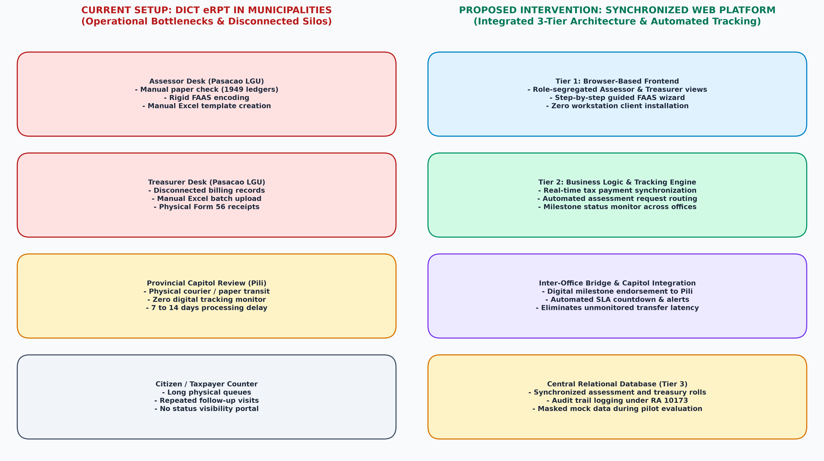
Figure 1. Architectural and Workflow Comparison: DICT eRPT Local Monolith Setup vs. Proposed System Three-Tier Synchronized Web Platform (Authors' Synthesis, 2026).
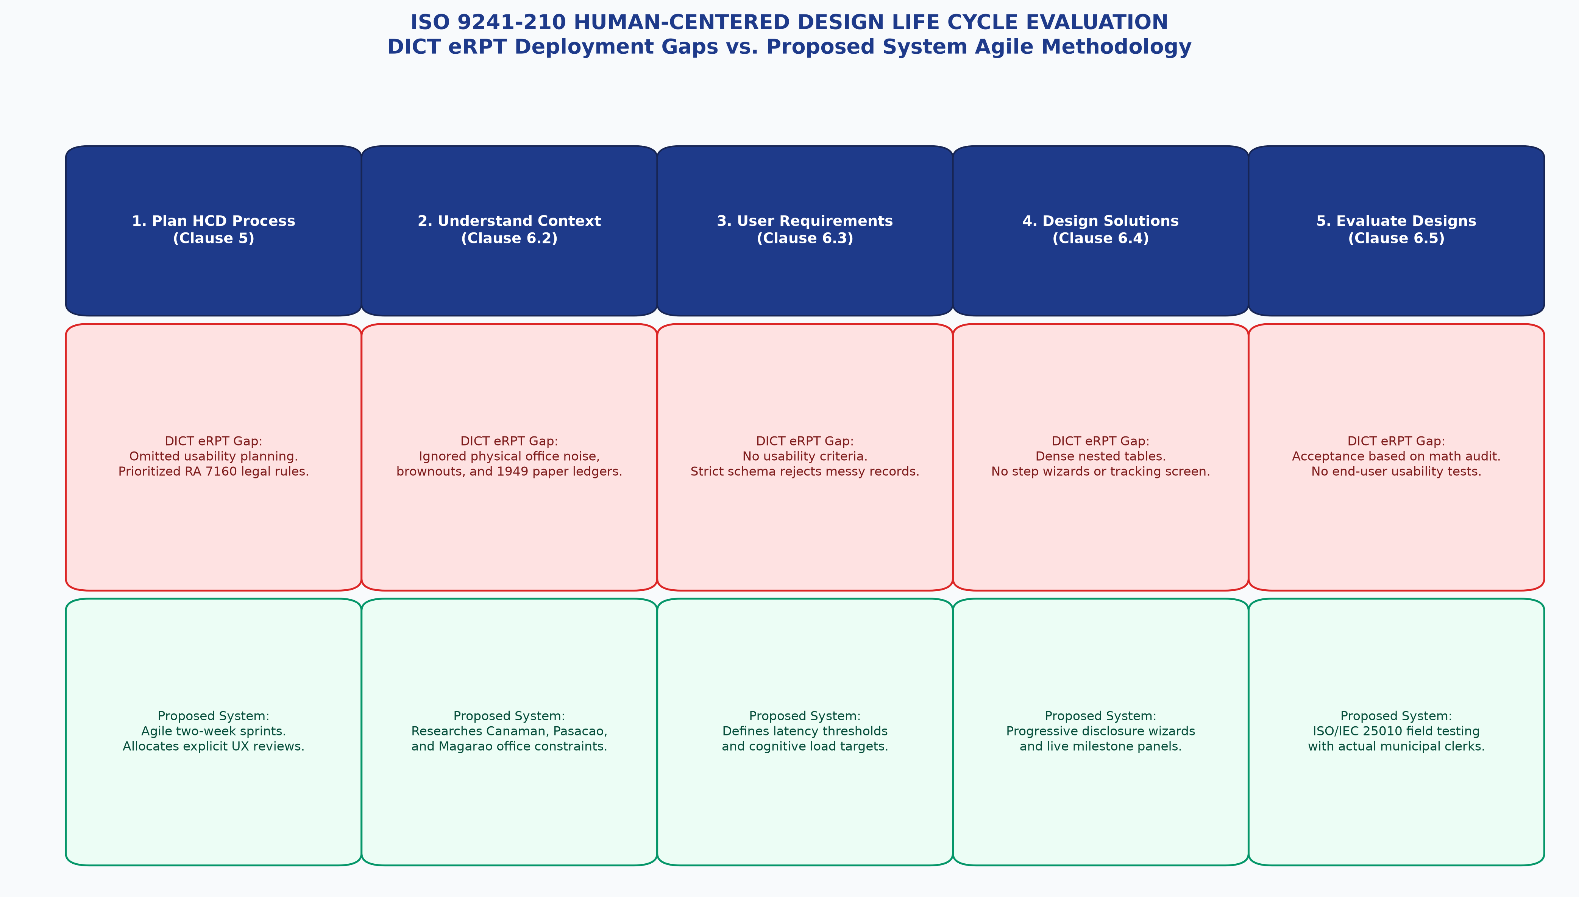
Figure 2. ISO 9241-210 Human-Centered Design Life Cycle Evaluation: DICT eRPT Deployment Gaps vs. Proposed System Agile Methodology (Authors' Synthesis, 2026).
Appendix 2: Formal References (ACM Style)
Norberto Arrocena Chinilla and Glenne Berja Lagura. 2025. Enhanced tax revenue assessment and collection system through the lens of the municipal treasurers and assessors. International Journal for Multidisciplinary Research (IJFMR) 7, 4 (2025), 1–42. DOI: https://doi.org/10.36948/ijfmr.2025.v07i04.51726
Department of Information and Communications Technology. 2023. Electronic Real Property Tax System (eRPT) Implementation Guidelines and Local Government Technical Standards. DICT, Quezon City, Philippines.
Department of Information and Communications Technology. 2023. Philippine e-Government Interoperability Framework (PeGIF): Technical Data and Information Interoperability Standards for Local Government Units. DICT, Quezon City, Philippines.
International Organization for Standardization. 2006. ISO 9241-110:2006: Ergonomics of human-system interaction — Part 110: Dialogue principles. ISO, Geneva, Switzerland.
International Organization for Standardization. 2010. ISO 9241-210:2010: Ergonomics of human-system interaction — Part 210: Human-centred design for interactive systems. ISO, Geneva, Switzerland.
International Organization for Standardization. 2025. ISO 19152-4:2025: Geographic Information — Land Administration Domain Model (LADM) — Part 4: Valuation Information. ISO, Geneva, Switzerland.
Ma. Angelica Mendoza. 2025. Comparative study on the manual and computer-assisted assessment of real property taxes in Victoria, Laguna. International Journal of Research Publications (IJRP) 173, 1 (2025), 1104–1148. DOI: https://doi.org/10.47119/10.47119/IJRP1001731520257969
Republic of the Philippines. 1991. Republic Act No. 7160: An Act Providing for a Local Government Code of 1991. Official Gazette of the Republic of the Philippines, Manila.
Republic of the Philippines. 2012. Republic Act No. 10173: Data Privacy Act of 2012. Official Gazette of the Republic of the Philippines, Manila.
Republic of the Philippines. 2024. Republic Act No. 12001: Real Property Valuation and Assessment Reform Act (RPVARA). Official Gazette of the Republic of the Philippines, Manila.
Maria Santos and Juan Reyes. 2024. Assessing administrative efficiency and revenue collection bottlenecks in municipal real property taxation. Philippine Journal of Public Administration 68, 2 (2024), 112–135.

